School Calendars

There are 2 ways to move your School Calendars.

- In the Next Pay Frequency > Tables > Workday Calendars > School Calendar tab must have 2 characters in the Calendar Code.
- To Correct the one-digit code to a two-digit code:
- Click on the +Add
- Ender a two-digit code – Example 1 to 01, 2 to 02 etc.

- Copy School Calendar Tab.
  - Enter Frequency
  - Select the Calendar Code you want to copy.
  - Save.
  - Repeat until you have copied all with a 2-digit code.

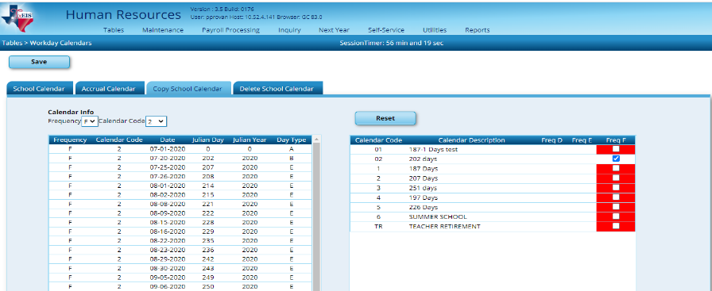

- Delete Calendars. Now you will want to delete the calendars that you just copied
Tables > Workday Calendars > Delete School Calendar
- Select the Calendars that you want to delete
- SAVE

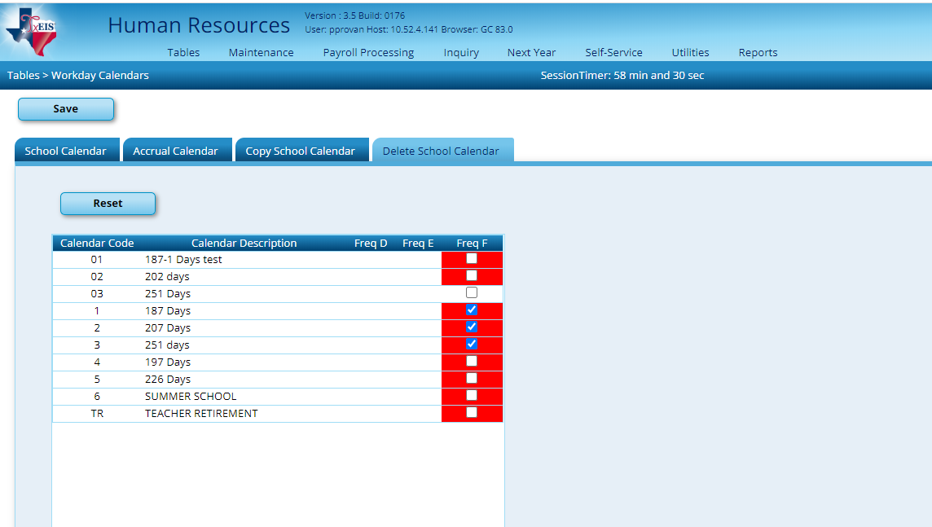

Now you are ready to Copy Next Year Tables to Current Year.

- If you do not choose step a. then due to a program issue, School Calendars must be moved separately.
- Uncheck tables that were just copied.
- Select the ellipses beside School Calendars.
- Select one calendar at a time and copy. Continue until all calendars except TR and Summer School have been copied (TR calendar will be copied in a later step).

